**Project Report Template**

INTRODUCTION:

* 1. CRM is a custom relationship management is the combination of practices, strategies and technologies that companies use to manage and analyse customer interaction and data throughout the customer life cycle.
  2. Customer relationship management(CRM) is a technology for managing all your company’s relationships and interactions with customers and potential customers. The goal is simple: Improve business relationship. A CRM system helps companies stay connected to customers, streamline processes, and improve profitability

2.PROBLEM DEFINITION & DESIGN THINKING

2.1 EMAPTHY MAP

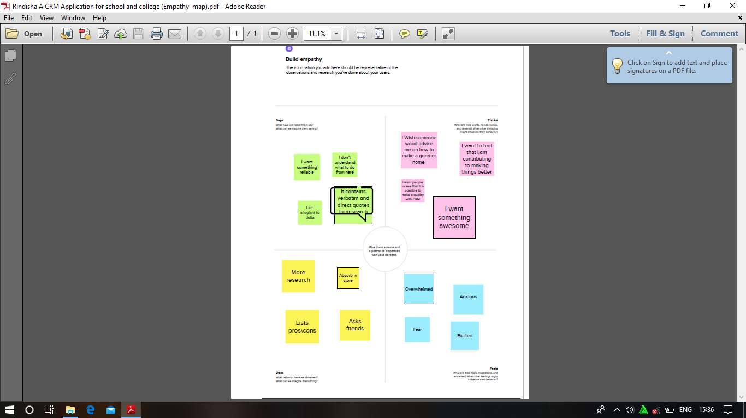

2.2 IDEATION &BRAIN STORMING MAP

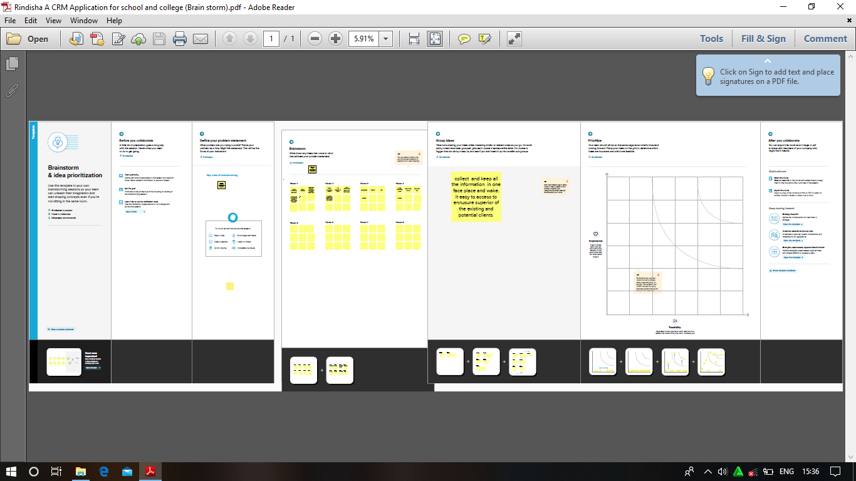

3.RESULT

3.1 Data Model

|  |  |
| --- | --- |
| Object Name | Fields In The Object |
| Obj 1:  School | |  |  | | --- | --- | | Fields Label | Data Type | | Address | Text Area | | Phone Number | Phone | | Number Of Students | Rool -Up Summary | |
| Obj 2:  Student | |  |  | | --- | --- | | Fields Label | Data Type | | Result | Pick List | | Class | Number | | Parent Address | Text Area | |

3.2 Activity & Screen shot

Milestone 1:

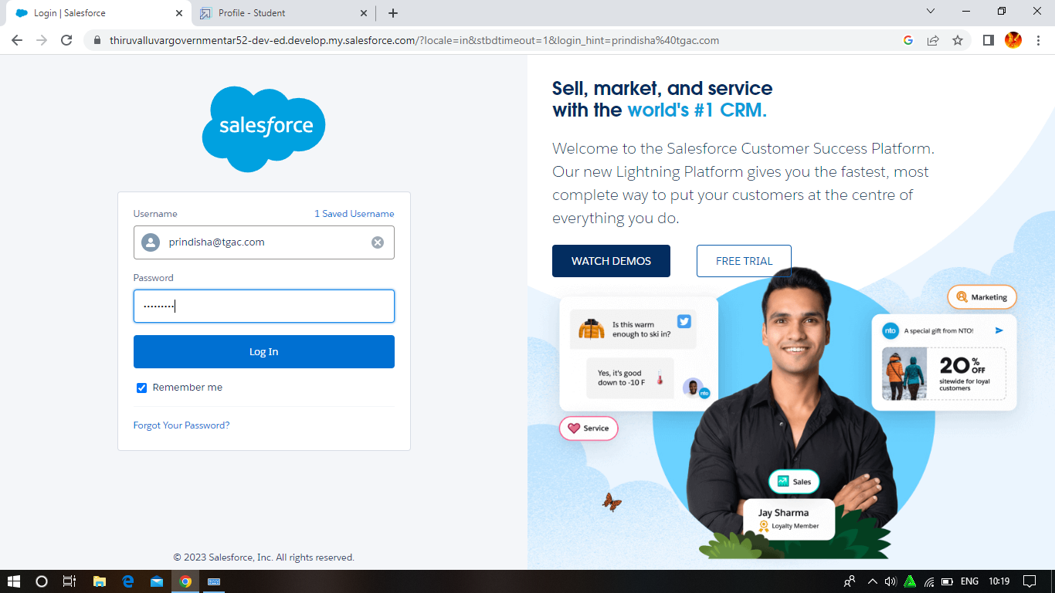

Milestone 2: Object

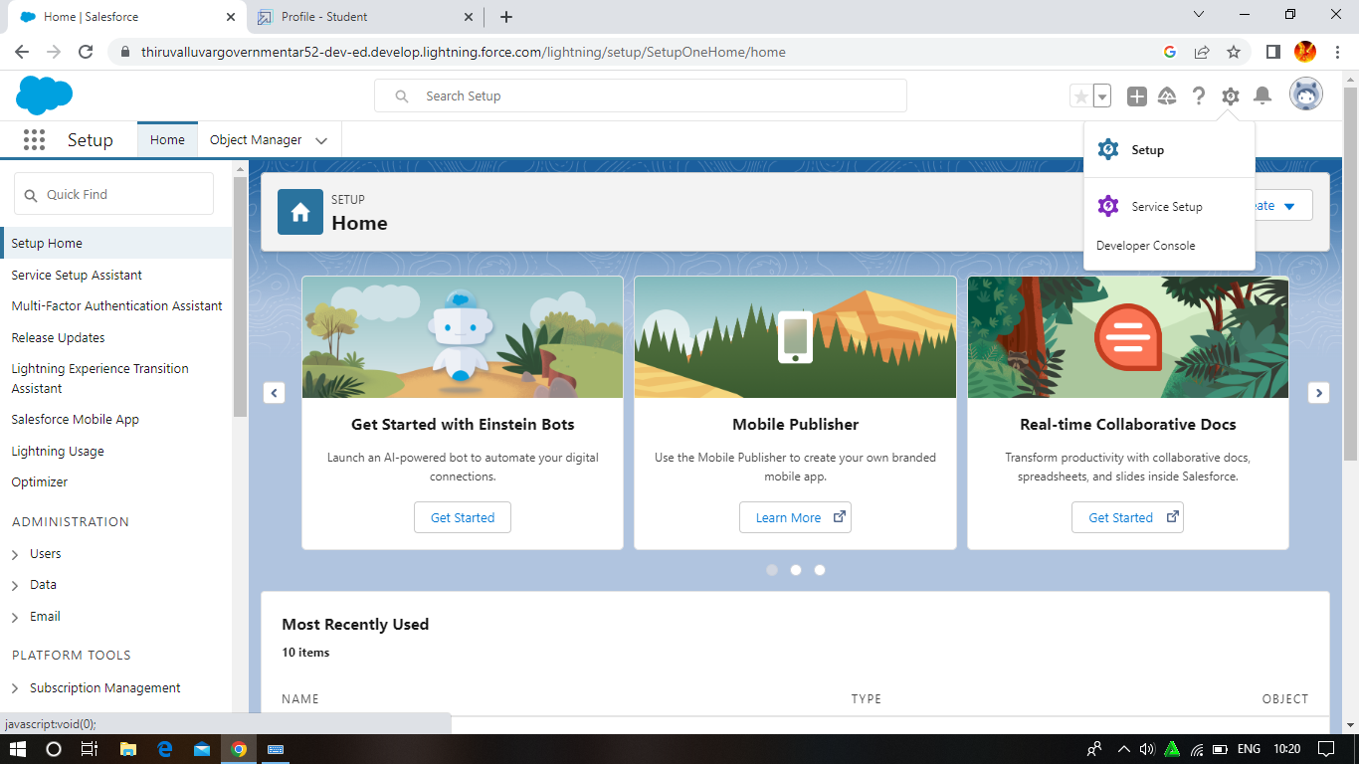

Milestone 3:Lighting App

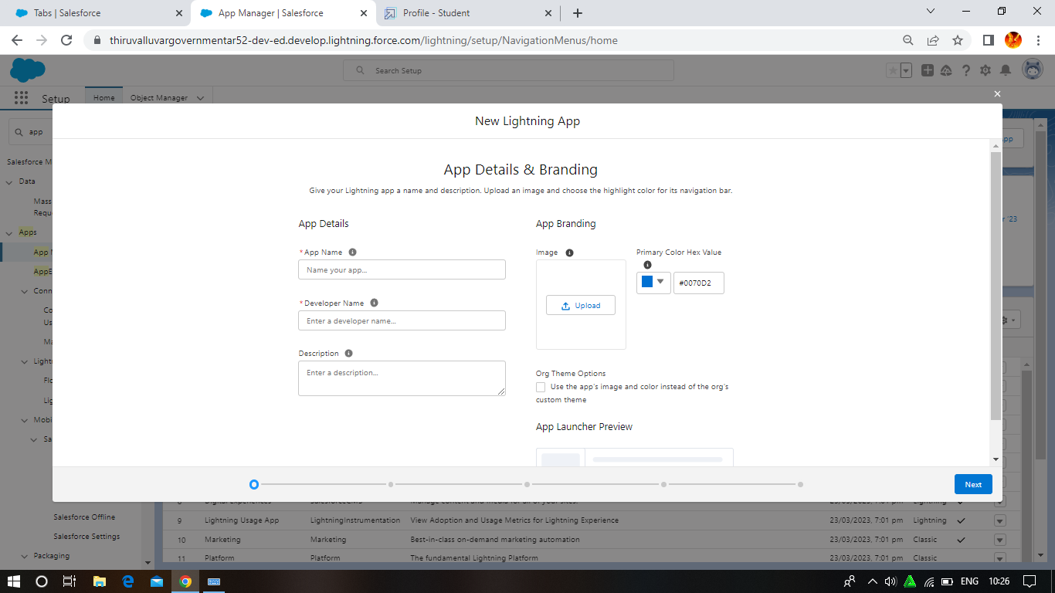

Milestone 4: Fields And Relationship

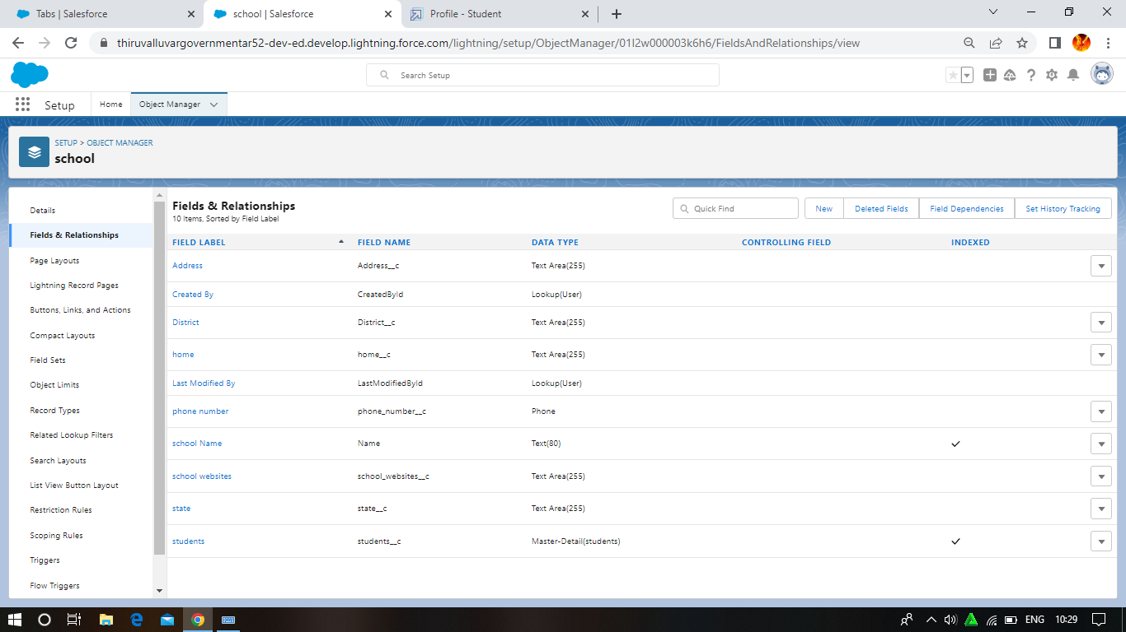

Milestone 5 : Profile

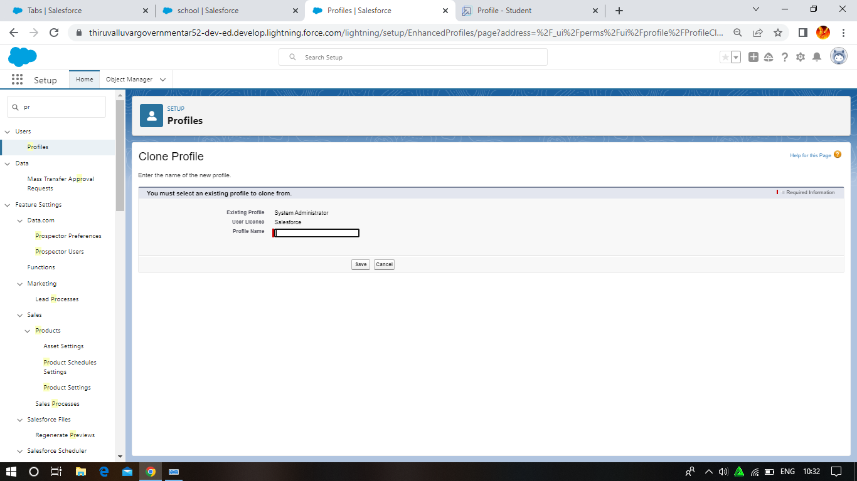

Milestone 6: Users

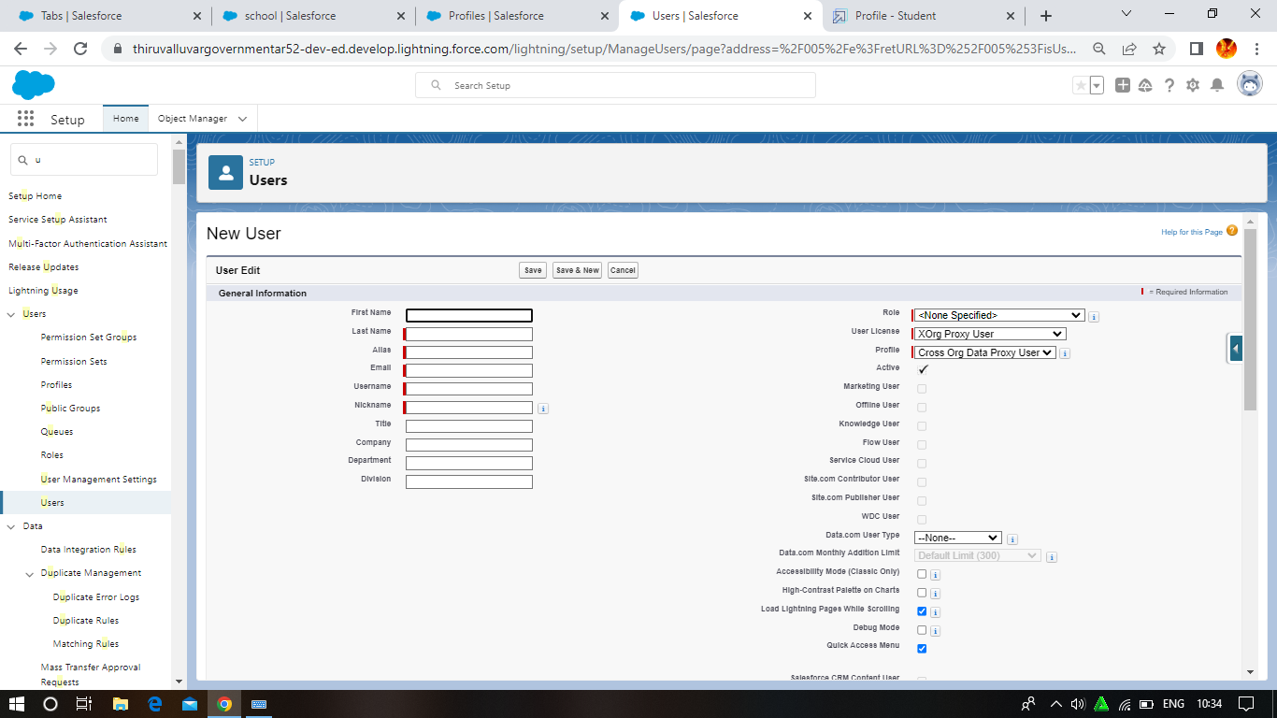

Milestone 7 :Premission sets

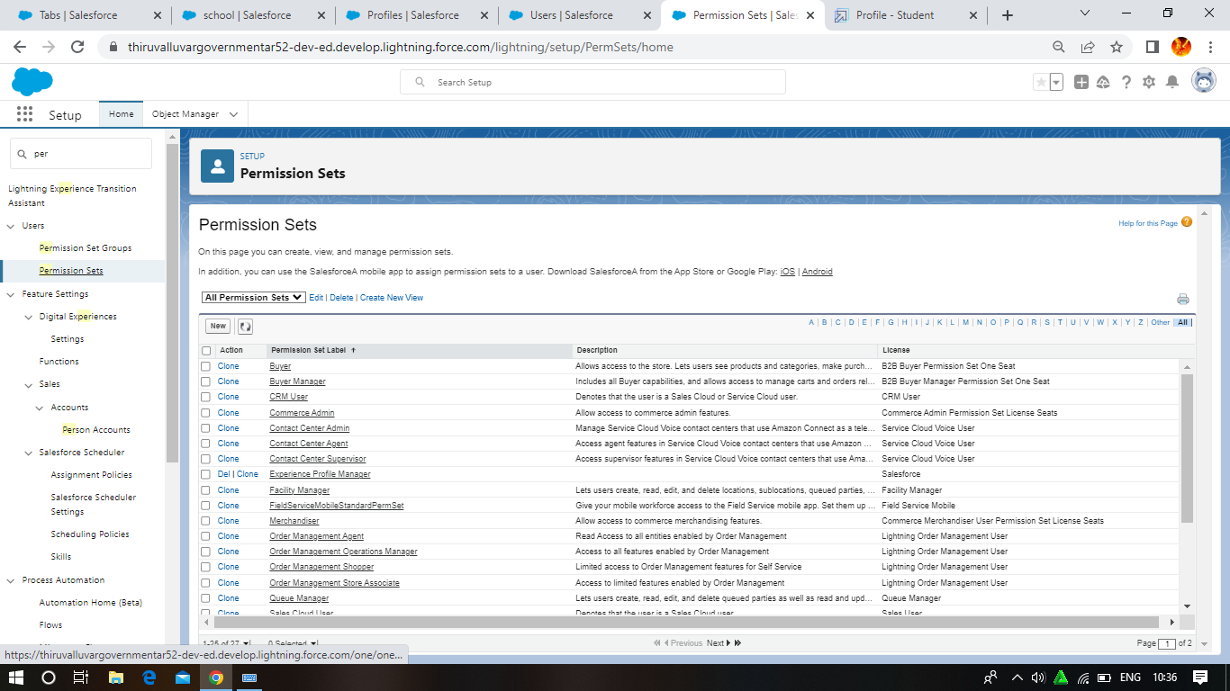

Milestone 8: Report

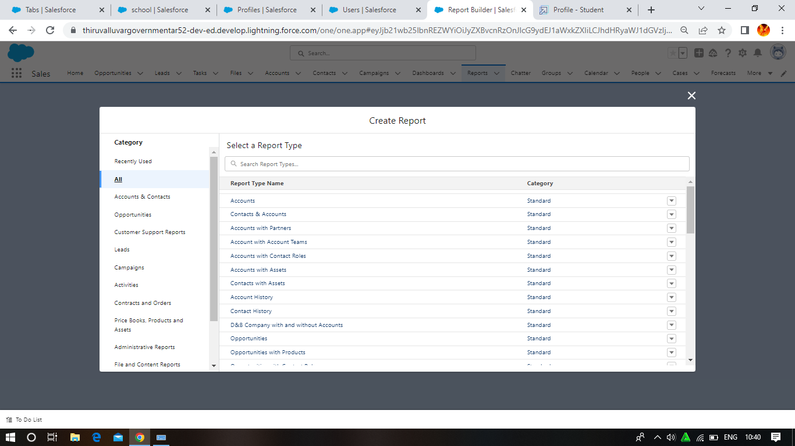

4. Trailhead Profile Public URL

Team lead - https://trailblazer.me/id/rindishaphytm

Team Member 1-http://trailblazer.me/id/kaliyammal

Team Member2-https://trailblazer.me/id/kaviyaphy

Team Member3-https://trailblazer.me/id/lalithapphytm

5. ADVANTAGES & DISADVANTAGE

Advantage

1)It allows for more effective sales and marketing .

2)It can speed up the sales conversion process

3)It increase staff productivity ,lowers time costs and boosts

4) It enables widely dispersed teams to work closely

5)Can improve customer loyalty through exceptional experience.

Disadvantage

1. It may not suit every business

2)It requires a process – Driven sales organisation.

3) Security concerns associated with centralised data

4)Staff over –reliance on CRM may diminish customer loyalty through and bad experience

5) The excess initial time and productivity cost of implementation

6. APPLICATION

1)CRM is a set of integrated

2) Data – Driven software solution that help manage ,track

And store information related to your company’s current and

Potential customers

7. CONCLUSION

Customer relationship management is a technology for managing all your company’s relationship and interactions with customers and potential customers

8. FUTURE SCOPE

A Scope of work document is an agreement on the work you’re going to perform on the project . A Scope of work in project management includes deliverables ,a timeline ,milestones and report